**Chapter 2:**

**Class Activity 1:**

**Class Activity 2:**

**Class Activity 3:**

**Class Activity 4:**

**Class Activity 5:**

**Chapter 3:**

**Class Activity 1:**

**Class Activity 2:**

**Class Activity 3:**

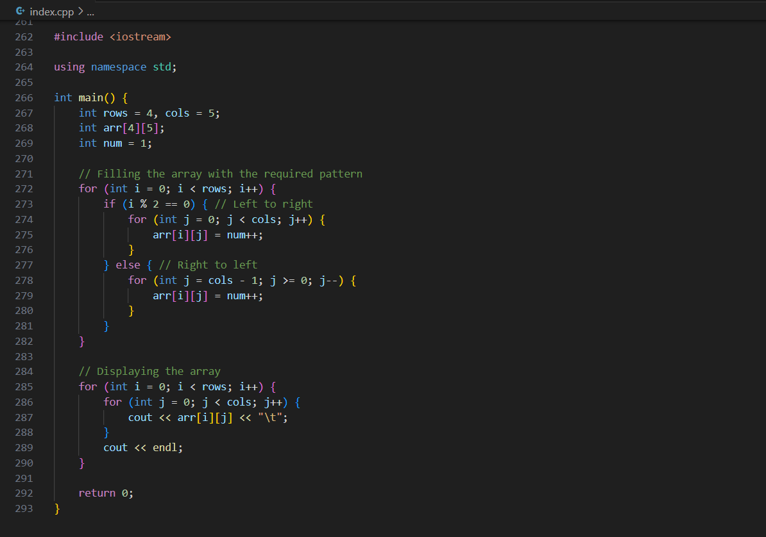

**Class Activity 4:**

**Class Activity 5:**



